Explain the concept of Serialization and Deserialization in Java with suitable example : 2016,2018 exam
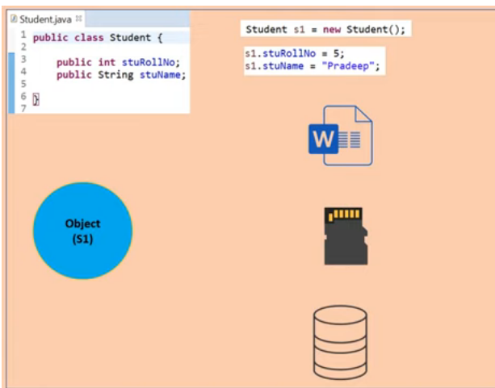

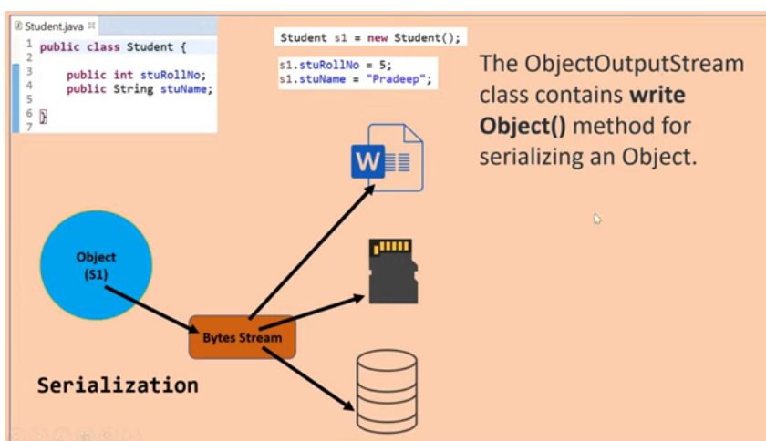

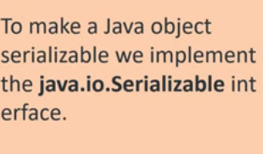

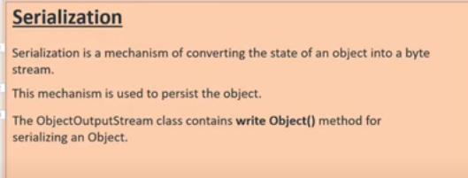

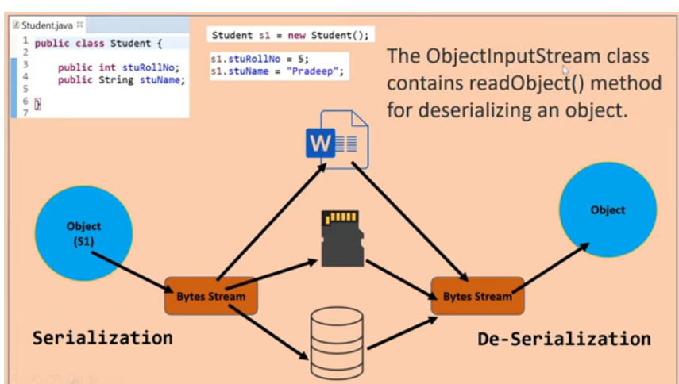

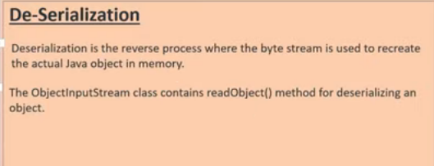

Serialization and Deserialization in Java
Serialization in Java is a mechanism of writing the state of an object into a byte-stream. It is mainly used in Hibernate, RMI, JPA, EJB and JMS technologies.
The reverse operation of serialization is called deserialization where byte-stream is converted into an object. The serialization and deserialization process is platform-independent, it means you can serialize an object in a platform and deserialize in different platform.
For serializing the object, we call the writeObject() method ObjectOutputStream, and for deserialization we call the readObject() method of ObjectInputStream class.
We must have to implement the Serializable interface for serializing the object.

Advantages of Java Serialization
It is mainly used to travel object's state on the network (which is known as marshaling).
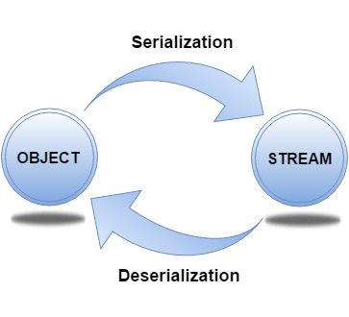

ObjectOutputStream class
The ObjectOutputStream class is used to write primitive data types, and Java objects to an OutputStream. Only objects that support the java.io.Serializable interface can be written to streams.

Constructor
1) public ObjectOutputStream(OutputStream out) throws IOException {} | creates an ObjectOutputStream that writes to the specified OutputStream.

Important Methods
Method | Description
1) public final void writeObject(Object obj) throws IOException {} | writes the specified object to the ObjectOutputStream.
2) public void flush() throws IOException {} | flushes the current output stream.
3) public void close() throws IOException {} | closes the current output stream.

ObjectInputStream class
An ObjectInputStream deserializes objects and primitive data written using an ObjectOutputStream.

Constructor
1) public ObjectInputStream(InputStream in) throws IOException {} | creates an ObjectInputStream that reads from the specified InputStream.

Important Methods
Method | Description
1) public final Object readObject() throws IOException, ClassNotFoundException{} | reads an object from the input stream.
2) public void close() throws IOException {} | closes ObjectInputStream.

In case of transient variables:- A variable defined with transient keyword is not serialized during serialization process.This variable will be initialized with default value during deserialization. (e.g: for objects it is null, for int it is 0).

Example of Java serialization

Java.io.Serializable interface
Serializable is a marker interface (has no data member and method). It is used to "mark" Java classes so that the objects of these classes may get a certain capability. The Cloneable and Remote are also marker interfaces.
It must be implemented by the class whose object you want to persist.
The String class and all the wrapper classes implement the java.io.Serializable interface by default.

Serialization of objects

Till now we handled the text files to read and write its contents .but what if we want to store structured data in the files?
Like we want store employee details like id(int type ),name (String type ),doj(date Type),sal (float type )… in a file.
This data structure contains different datatypes.
- To store such data we need to create a class Employee with the instance variables id,name,doj,sal..
class employee implements Serializable{
int id;
String name;
float sal;
Date doj;
}
‘

HERE, Student class implements Serializable interface.means Serializable interface should be implemented by class whose object are to be stored into the file. Now its objects can be converted into stream.

Step I WAP to create a class Student whose object are to be stored into a file //student.java
package streamprg;
import java.io.*;
import java.io.Serializable;

class student implements Serializable{
int id;
String name;
public student(int id, String name) {
this.id = id;
this.name = name;
}
void display()
{
System.out.println(id + "\t" + name);
}
static student getdata() throws IOException{

InputStreamReader isr=new InputStreamReader(System.in);
BufferedReader br=new BufferedReader(isr);

//BufferedReader br=new BufferedReader(new //InputStreamReader(System.in));
System.out.println("ENTER ID");
int id=Integer.parseInt(br.readLine());
System.out.println("ENTER name");
String name=br.readLine();
student s1 =new student(id,name);
return s1;
}
}
Step II WAP to show serialization of objects. (serialize.java)
package streamprg;
import java.io.*;
import java.util.*;
public class serialize {
public static void main(String args[]){
try{

InputStreamReader ir=new InputStreamReader(System.in);
BufferedReader br=new BufferedReader(ir);
System.out.println("ENTER no of obj");
int n=Integer.parseInt(br.readLine());

//Creating the object

//Creating stream and writing the object
FileOutputStream fout=new FileOutputStream("o1.txt");
ObjectOutputStream out=new ObjectOutputStream(fout);

for(int i=0;i<n;i++)
{
student s1 =student.getdata();

out.writeObject(s1);
}
out.flush();
//closing the stream
out.close();
//System.out.println("success");
}catch(Exception e){System.out.println(e);}
}
}

Output
Javac student.java
Javac serialize.java
Java serialize
ENTER no of obj
3
ENTER ID
101
ENTER name
pooja
ENTER ID
102
ENTER name
chandani
ENTER ID
103
ENTER name
harshit

Example of Java Deserialization
Deserialization is the process of reconstructing the object from the serialized state. It is the reverse operation of serialization. Let's see an example where we are reading the data from a deserialized object.
package streamprg;
import java.io.*;
import java.util.*;
public class deserialize {
public static void main(String args[]) throws Exception{
FileInputStream fout=new FileInputStream("o1.txt");
ObjectInputStream out=new ObjectInputStream(fout);
try {
student e;
while((e= (student)out.readObject())!=null)
{
e.display();
}

}catch(Exception ee) {
System.out.println("End ");}

finally {
//closing the stream
out.close();
//System.out.println("success");
}

}}
OUTPUT
101 pooja
102 chandani
103 harshit

